***ICT LAB 11 TASKS:***

***NAME: YASH RAJ***

***ROLL NUMBER: 24K-0737***

1. ***ZOO MANAGEMENT SYSTEM:***

***#include <iostream>***

***#include <string>***

***using namespace std;***

***class Animal {***

***private:***

***string name;***

***int age;***

***public:***

***void setName(const string &n) { name = n; }***

***void setAge(int a) { age = a; }***

***void displayInfo() const {***

***cout << "Name: " << name << ", Age: " << age << endl;***

***}***

***};***

***class Mammal : public Animal {***

***public:***

***void feedBaby() const {***

***cout << "Feeding baby mammal." << endl;***

***}***

***};***

***class Bird : public Animal {***

***public:***

***void layEgg() const {***

***cout << "Laying an egg." << endl;***

***}***

***};***

***class Reptile : public Animal {***

***public:***

***void shedSkin() const {***

***cout << "Shedding skin." << endl;***

***}***

***};***

***int main() {***

***Mammal mammal;***

***Bird bird;***

***Reptile reptile;***

***mammal.setName("Panda");***

***mammal.setAge(5);***

***mammal.displayInfo();***

***mammal.feedBaby();***

***bird.setName("Gray Parrot");***

***bird.setAge(2);***

***bird.displayInfo();***

***bird.layEgg();***

***reptile.setName("Snake");***

***reptile.setAge(3);***

***reptile.displayInfo();***

***reptile.shedSkin();***

***return 0;***

***}***

***OUTPUT:***

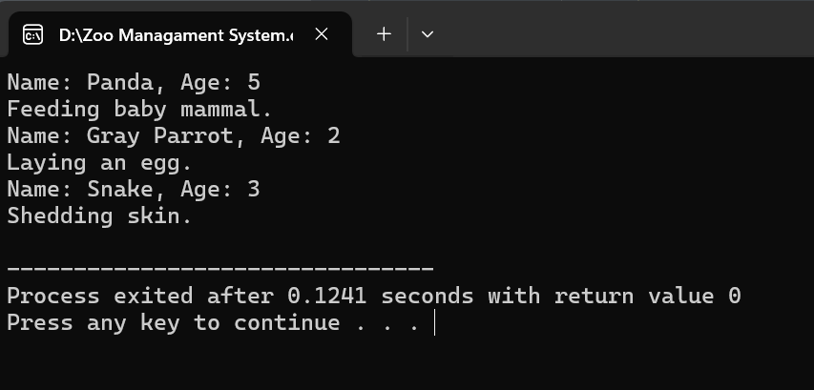

1. ***STUDENT AND EMPLOYEE MANAGEMENT SYSTEM:***

***CODE:***

***#include <iostream>***

***#include <string>***

***using namespace std;***

***class Person {***

***private:***

***string name;***

***int age;***

***public:***

***void setName(const string &n) { name = n; }***

***void setAge(int a) { age = a; }***

***void displayInfo() const {***

***cout << "Name: " << name << ", Age: " << age;***

***}***

***};***

***class Employee : public Person {***

***private:***

***int employeeID;***

***public:***

***void setEmployeeID(int id) { employeeID = id; }***

***void displayInfo() const {***

***Person::displayInfo();***

***cout << ", Employee ID: " << employeeID << endl;***

***}***

***};***

***class Student : public Person {***

***private:***

***int studentID;***

***public:***

***void setStudentID(int id) { studentID = id; }***

***void displayInfo() const {***

***Person::displayInfo();***

***cout << ", Student ID: " << studentID << endl;***

***}***

***};***

***int main() {***

***Person person;***

***person.setName("ADR");***

***person.setAge(40);***

***cout << "Person Info: ";***

***person.displayInfo();***

***cout << endl << endl;***

***Employee emp;***

***emp.setName("SAAD");***

***emp.setAge(30);***

***emp.setEmployeeID(101);***

***cout << "Employee Info: ";***

***emp.displayInfo();***

***cout << endl;***

***Student stud;***

***stud.setName("Yash Raj");***

***stud.setAge(19);***

***stud.setStudentID(202);***

***cout << "Student Info: ";***

***stud.displayInfo();***

***cout << endl;***

***return 0;***

***}***

***OUTPUT:***

